An ordinance for all road purposes for Burton Township Road District, McHenry County, Illinois, for the fiscal year beginning April 1, 2020 and ending March 31, 2021.

BE IT ORDAINED by the Board of Trustees of Burton Township, McHenry County, Illinois.

SECTION 1: That the amounts hereinafter set forth, or so much thereof as may be authorized by law, and as may be needed or deemed necessary to defray all expenses and liabilities of Burton Township Road District, be and the same are hereby appropriated for road purposes of Burton Township Road District, McHenry County, Illinois, as hereinafter specified for the fiscal year beginning April 1, 2020 and ending March 31, 2021.

SECTION 2: That the following budget containing an estimate of revenues and expenditures is hereby adopted for the following funds;

GENERAL ROAD FUND
PERMANENT ROAD FUND
BUILDING AND EQUIPMENT FUND
ROAD DAMAGE FUND

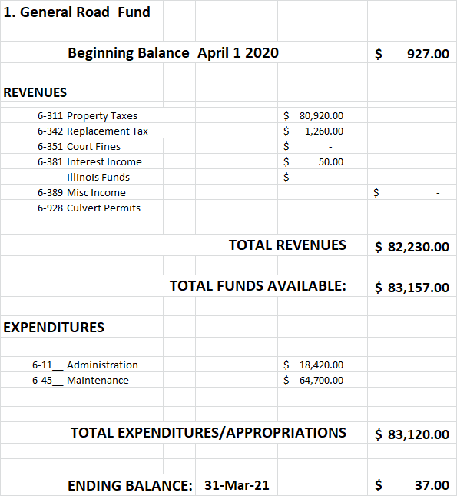

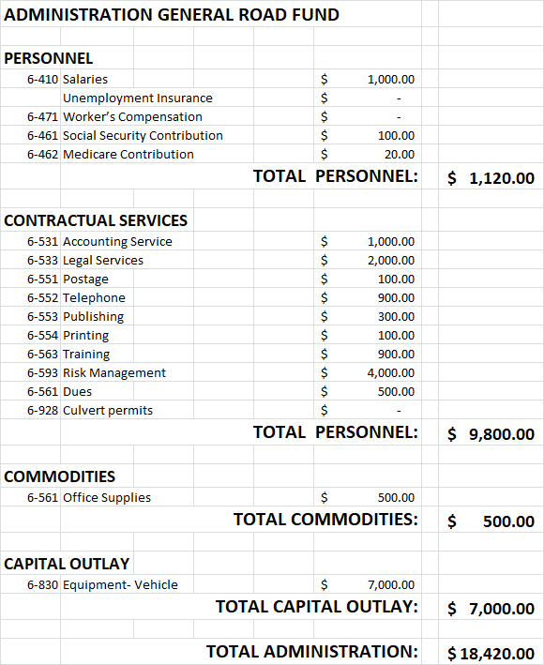

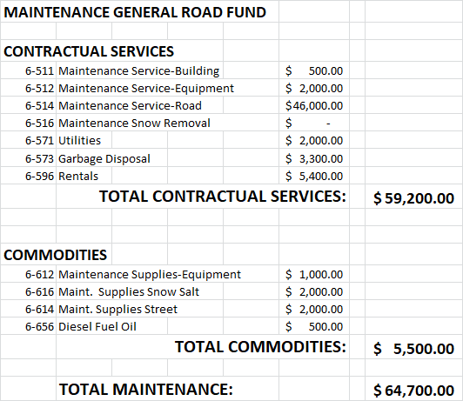

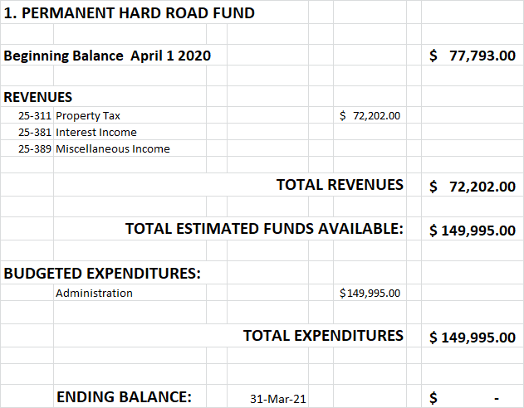

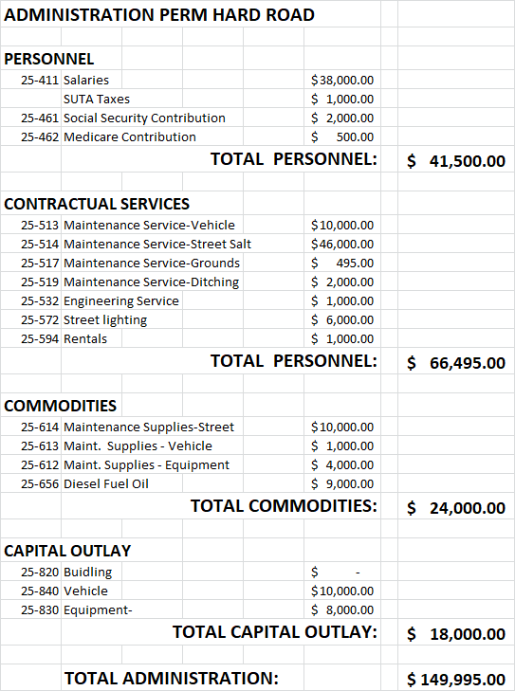

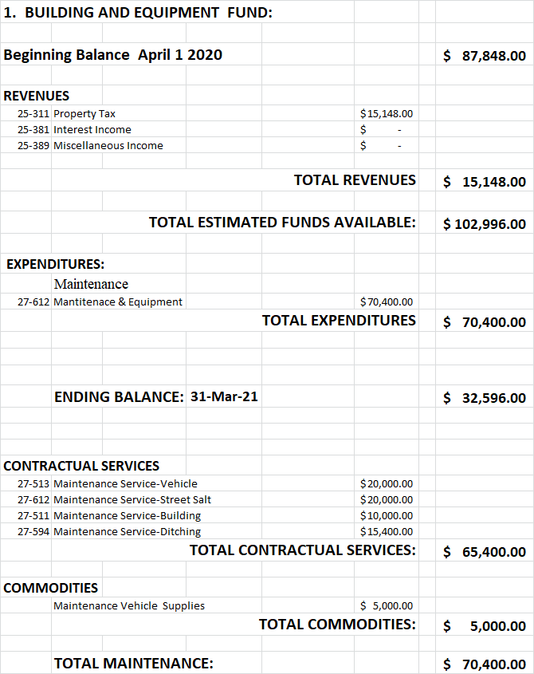

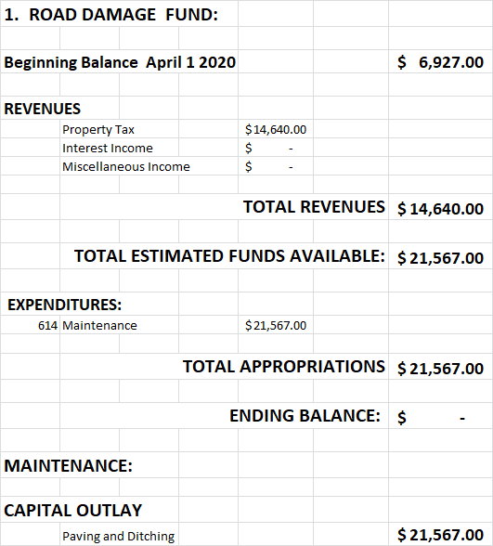

Section 3: That the amount appropriated for road purposes for the fiscal year beginning April 1, 2020 and ending March 31, 2021 by fund shall be as follows:

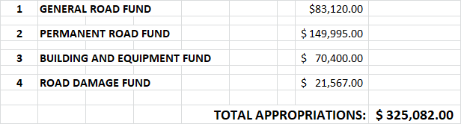

Section 4: That if any section, subdivision, or sentence of this ordinance shall for any reason be held invalid or to be unconstitutional, such decision shall not effect the validity of the remaining portion of this ordinance.

Section 5: That each appropriated fund total shall be divided among several objects and purposes specified, and in particular amounts stated for each fund respectively in section 2 constituting the total amount of Three Hundred Twenty Five Thousand, Eighty-two Dollars ($325,082.00) for the fiscal year beginning April 1, 2020 and ending March 31, 2021.

Section 6: That Section 3 shall be and is a summary of the annual Appropriation Ordinance, of this road district, passed by the Board of Trustees as required by law and shall be in full force and effect from this date.

Section 7: That a certified copy of the Budget and Appropriation Ordinance must be filed with the County Clerk within 30 days after adoption.
